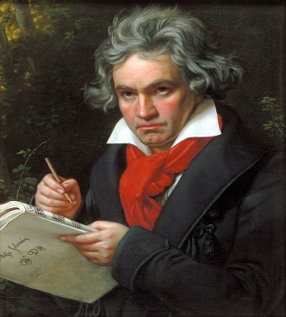
Beethoven
Beethoven displayed his musical talents at an early age and was taught by his father Johann van Beethoven .
He was a classical composer and a pianist; he remains one of the most famous and influential composers
At the same time as he was composing these great and immortal works, Beethoven was going deaf. By the turn of the century, he struggled to make out the words spoken to him in conversation.
